Financial Accounting
Pg. 90 Problem #3-30
Keith Geiser

Part A
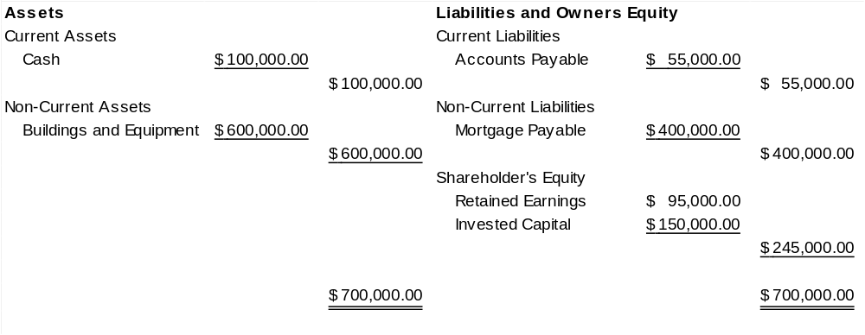

Part B
Most businesses would not have such a limited balance sheet. A company of this size would certainly have other categories necessary to a balance sheet.

Part C
A company of this size that is service related would, in all probability, have defined on their balance sheet categories such as, income tax payable, prepaid expenses, warranty obligation, inventory, etc.
A service company might provide an employee with an expense account. This account would be for the use of their personal vehicle on the job. Alternately, a manufacturing company would probably need to reflect a budget set aside for equipment repair.

